1. One Alternative is to use any site specific Progress Notes, but still use AWARE Reminder Dialog elements as a common method to account for follow-up actions completed.

After a note is completed,i.e. say for a FOBT IMMUNOASSAY LETTER note , and before a signing , using the Template drawer to initiate the AWARE FOBT-Fit Reminder Dialog Template to make a follow-up action for the “entering of a specific Progress Note Title entry, and the subsequent making of a Health Factor (HF) for the visit of the completed Progress note.

**Impact:**

**Advantages/Disadvantages:**

Each Progress Note Title designated for AWARE use with an Alert type or for all Alert types with the same “Generic” Alert type could have a dialog element added to the associated AWARE Reminder Dialog, one entry for each possible designated Progress Note Title.

Each Progress Note Title does not have to be unique for AWARE use only. For example with a “PACT Telephone Clinic” note with FOBT related follow-up action, only if the Template drawer is opened with selection of the AWARE FOBT-FIT Reminder Dialog Template will a HF for an entered “PACT Telephone Clinic” note associated with FOBT activity be recorded. So a “PACT Telephone Clinic” note can be used for other purposes other than just for AWARE use. There does not have to be a unique Progress Note title for AWARE use in a telephone clinic visit (such as “PACT FOBT Telephone Clinic” note).

The AWARE Follow-ups Reminder dialog group can have added Reminder Dialog elements for commenting that certain Progress Note (titles) were entered as a kind of follow-up action. HFs can be made, and added for such comments as Additional Findings in the respective Reminder Dialog elements.

For example, “FOBT IMMUNOASSAY LETTER note entered” , or “PACT Telephone Clinic” note entered” comment Reminder Dialog elements can be entered with analogous comment text along with associated and appropriate AW500 FOBT named HFs.

*No AWARE software changes needed with continued use only with AWARE Reminder Dialog Template elements (orders and HF text data elements) as common method of ALERT tracking and with CPRS –AWARE prompting for redirection to do follow-up activities upon patient closeout.

No Knowledge Base configuration needed either with list of Progress Note titles, or searching for these progress notes in both the Alert tracker and CPRS-AWARE dll.

General Instructions can be provided by Harris in the VistA Configuration Guide for making these additional Reminder Dialog elements.

See example below:

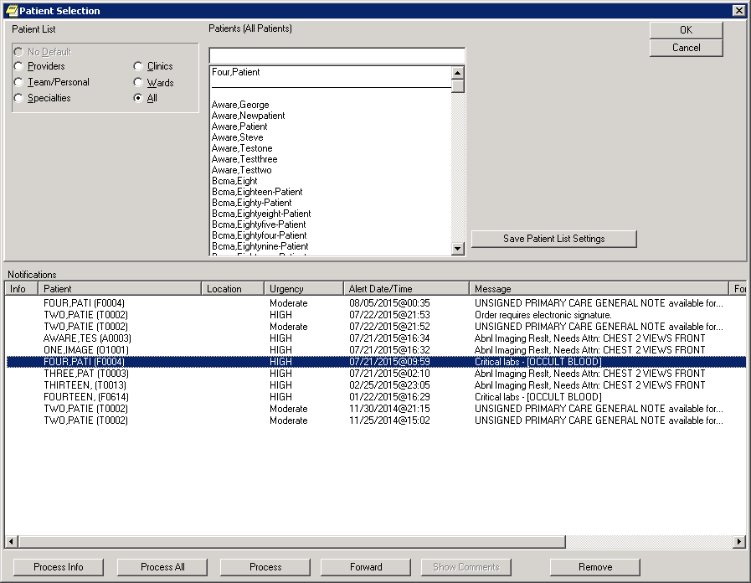

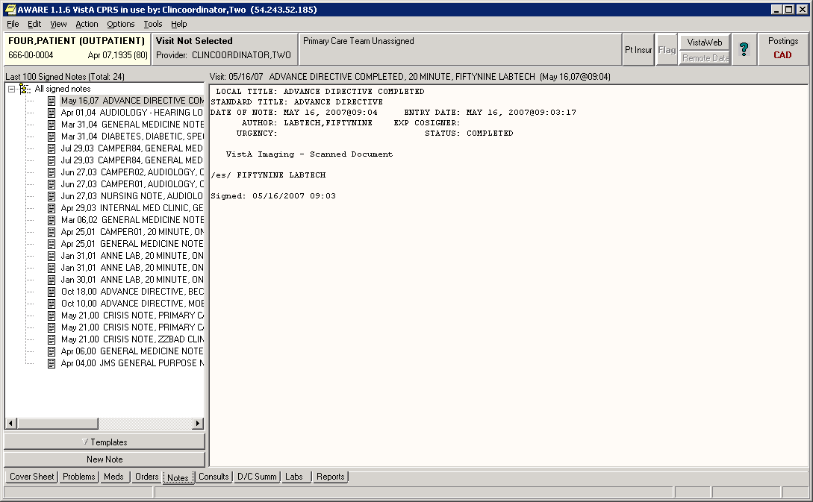

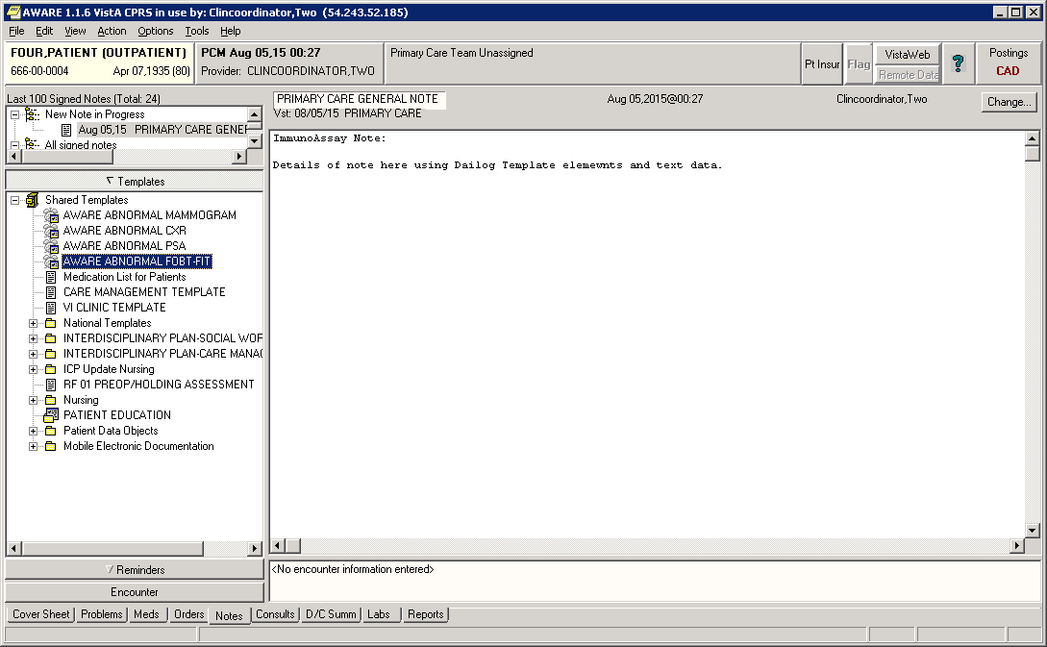

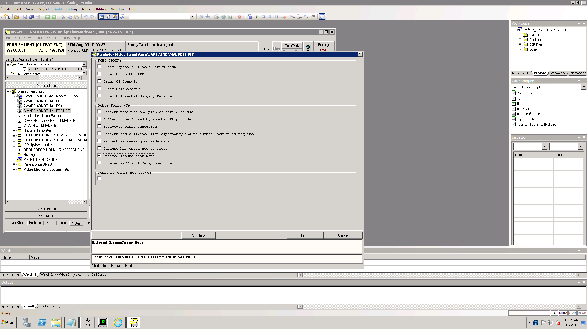

1. An alternative to allow specific Progress Note entry but still using AWARE Reminder Dialog elements for checking follow-up actions.

Automatically enter HF from specific Note Title, the same HF which is equivalent as if entered from an AWARE Reminder Dialog for a “Note” Entry” follow-up action. This is done with a TIU object placed on note that writes the HF into same visit. (i.e. AW500 OCC IMMUNOAASAY NOTE Health Factor (HF) and same named TIU Object)

**Impact:**

**Advantages/Disadvantages:**

Harris could provide a general Template TIU object which could be customized by Site staff. This work needed is a combination of programmer efforts to edit the Mumps code with the TIU object to satisfy the site’s customized needs, and a CAC/Clinical Informatics person’s placement of this TIU object on a Progress Note’s boilerplate text, or on any associated TIU Dialog Type Template with the Progress Note Title.

Progress Note Titles must be unique for each Alert type or group of alert types as a “Generic” Alert type, and reserved only for AWARE use since an AWARE specific TIU object will be placed on the Progress Note (Title).

*No AWARE software changes needed with continued use only with AWARE Reminder Dialog Template elements (orders and HF text data elements) as common method for ALERT tracking and CPRS –AWARE prompting for redirection to do follow-up activities upon patient closeout.

No Knowledge Base configuration needed either with list of Progress Note titles, and no searching for these progress notes in both the Alert tracker and CPRS-AWARE dll.

General Instructions could be provided by Harris in the VistA Configuration Guide.

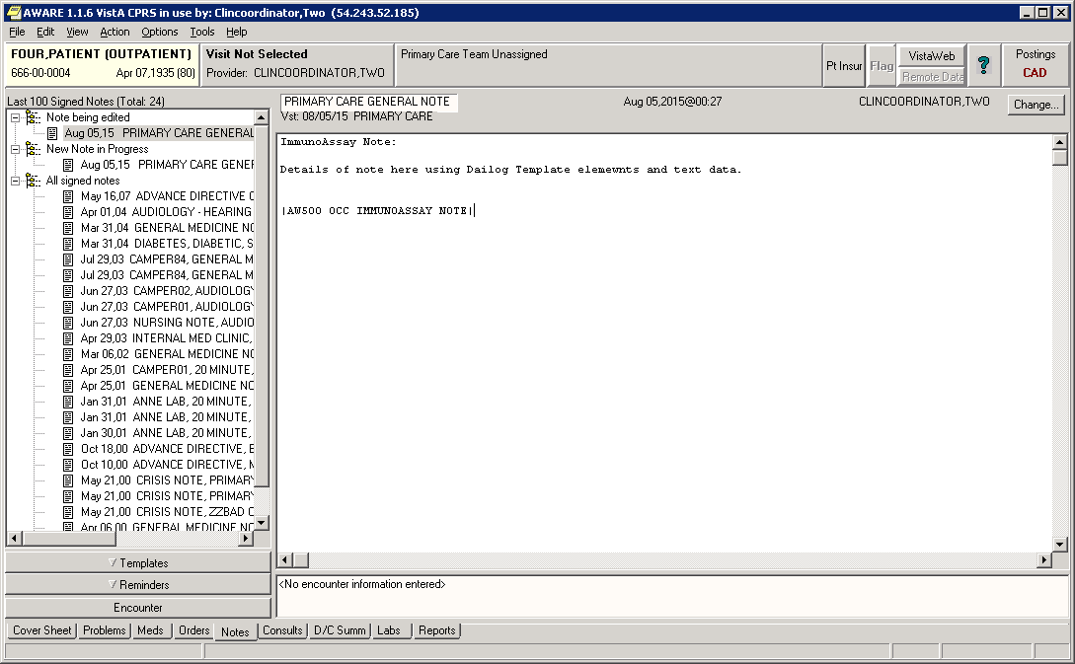

1. An Alternative with Site Specific Progress Note Title entry as Follow-up action in itself. Use entry of a signed Progress Note having a Site specific Progress Note Title for AWARE

Alert tracking and Patient Closeout Follow-up action checking in CPRS-AWARE.

**Impact:**

**Advantages/Disadvantages:**

**Advantage:** Allow alternative AWARE method beyond the common Reminder Dialog entry method of doing follow-up actions.

**Disadvantage:** Progress Note entry would be an additional non-Reminder dialog type follow-up action (if not also accounted for with an extra Reminder Dialog element for a “Specific Progress Note Entered” follow-up action).

This is additional logic checking when the Reminder Dialog method itself is able to represent any site customization already. Orders/HFs follow-up actions in AWARE Reminder Dialogs now already provide a way to allow site flexibility with different site specific follow-up actions taken. There is no existing HF associated with a Site Specific Progress Note (Title) being entered and signed. The Note itself would have to be searched in time and captured as a separate and different kind of follow-up action (not a HF).

Reminder Dialogs themselves for different AWARE alert types, or same “Generic” alert type can provide whole collections of possible follow-up actions with separate “compartmented” sections for different stages of follow-up for various purpose such tobacco screening, initial lung cancer screening, low dose CAT scan follow-up.

Also the capture of elements from other associated and existing site specific reminder dialogs already employed can be allowed when these extra follow-up action elements are also additionally incorporated in the associated AWARE Reminder Dialog(s). Specific Progress Note entry would not in itself be included in these collections (unless it is representatively added as a Reminder Dialog element too like “FOBT IMMUNOASSAY LETTER Note Entered”).

There also seems to major site differences in Imaging alert type follow-ups which maybe could be better “compartmented” within standard Reminder Dialog logic instead of elsewhere. Long Beach has both a combined Code 1 Tumor & Code 1 local implementations of follow-up processing along with a National “Abnormal Imaging Reslts Need Attn:” type addressing with follow-up actions. Charleston has even different objectives with Local codes for pulmonary nodule tracking (L1, L1-A, L2, L2-A, etc.) follow-up processing combined with different follow-up processing for National “generic” codes (4, 5, &8) and National “specific” codes such as BI-Rad codes (1100-1106).

Would the defined Progress Note Title have to be unique for each Alert Type or at least for each “Generic “Alert type? Yes. Also, each Progress Note Title must be reserved only for AWARE use.

*AWARE software “follow-up action” changes are needed in addition to AWARE Reminder Dialog Template elements (orders and HF text data elements) being checked for completed follow-up actions. Searches needed for completed and signed progress notes with unique Progress Note Titles specifically defined for AWARE use.

Knowledge base configuration needed with list of Progress Note titles to use per Alert type, and logic for searching for these progress notes would have to be added in both the Alert Tracker and CPRS-AWARE dll components. Distribution of new CPRS-AWARE dll may be needed, but it may also be possible that only Mumps routines for the underlying RPCS called by the CPRS-AWARE dll would need modifying (this also helps with not having to re-distribute a new CPRS-AWARE dll to the workstations).

Harris personnel can provide general Instructions as aids in the VistA Configuration Guide and the Knowledge Base User’s Guide.

1. An Alternative for using an Addendum attached to prior Progress Note entry with original Order to document follow-up actions and adding already existing AWARE Reminder dialog entry(s)

from this Addendum.

Allow date/time start for checking for follow-up action to be at a visit date/time associated with the original note with signed addendum to a note.

Could start check for visit date/time 1 week before Alert Date/time to account for delay from ordering to order resulting.

Logic would entail looking for a visit with a note & addendum for involved patient and author as ordering provider.

Addendum text not checked, but just HFs and signed orders made thru called up data entry with AWARE Reminder Dialog elements called thru Template Drawer

and “Shared” TIU Template folder from this Addendum to a previous Progress Note with original visit date/time.

**Impact:**

**Advantages/Disadvantages:**

Allow alternative AWARE method other than initial and common Reminder Dialog entry method associated now only with a NEW visit with date/time after the date/time of Alert.

Reminder Dialog should be invoked for entering specific follow-up actions by manually opening the “Shared” TIU Template drawer, then the appropriate AWARE TIU Reminder Dialog Template to allow entering of particular follow-ups as Reminder Dialog elements (with their orders and HFs).

New visit would not have to be a required in case there were issues with needed accounting for “Action still required” visits, or conflicts with non-billable visits (i.e. Medicare unaccounted and non-reimbursable visits). Instead addendum could be added to a previous existing note (visit) or scheduled appointment visit.

CPRS AWARE re-direction to an AWARE “New Visit” tab on Location Prompt could be manually changed by user to a “Previous Visit” tab for a selection of a prior visit, or appointment for then making an Addendum to an existing Progress Note with that visit.

No unique Progress Note Title(s) per site.

*AWARE software changes are needed for “backing up the start date for checking for follow-up actions after finding pertinent visit with an added Addendum to relevant Progress note and its visit with proper patient and ordering provider”. Searches needed first for the completed and signed addendum to this relevant progress note to get the appropriate visit date/time to start checking for a “Progress Note Addendum Made” type follow-up.

Use same Reminder Dialog Template elements (orders and HF text data elements) as only source of “follow-up” actions.

No Knowledge base updates needed is this could be a generic feature for all sites (unless we make feature this site configurable, “Yes/No”).

No unique Progress Note Titles. All accepted with addendum allowed on any Progress Note Title.

Logic could affect CPRS AWARE “re-direction” logic (in CPRS 30B version most likely) to allow making an Addendum to an existing Note from a previous Visit. Visit has to be within a defined period allowed before an AWARE Alert occurrence (say for a 1 week period at most before Alert occurrence).

Logic changes would affect both CPRS AWARE dll (only Mumps logic hopefully with no new DLL required), and AWARE Alert Tracker for gathering and processing data for the Alert Cache.

1. An Alternative for using screening on Primary Diagnostic Code with an Imaging Alert type through a provided site list of allowed Primary Diagnostic Codes accepted for each Alert Type defined from the KB Editor.

The “Alert Value” field now has been updated with Primary Diagnostic Code as assigned through Radiology Interpreting Staff so that particular screening can allow only the Alerts having an Alert value among ones in this list.

**Impact:**

**Advantages/Disadvantages:**

Screening to pick Abnormal Imaging Alerts that sites are targeting to be tracked with certain Primary Diagnostic Codes, and not for other extraneous conditions, and maybe not for “cancer” affiliated conditions including with no “tumor” or “cancer” codes being assessed, or for another type condition like “cardiomegaly”, etc.

AWARE Reminder Dialogs themselves for different AWARE Alert types, or same “Generic” Alert type can provide whole collections of possible follow-up actions with separate “compartmented” sections for different stages of follow-up for various purpose such tobacco screening, initial lung cancer screening, low dose CAT scan follow-up. Also the capture of elements from other associated and existing site specific reminder dialogs already employed can be allowed when these extra follow-up action elements are also additionally incorporated in the associated AWARE Reminder Dialog(s).

With “Primary Diagnostic Code” screening there seems to a way to customize site differences in Imaging alert type follow-ups which are “compartmented” within standard Reminder dialog logic (and not elsewhere):

Long Beach has both a combined Code 1 Tumor & Code 1 local implementations of follow-up processing along with a National “Abnormal Imaging Reslts Need Atn:” type addressing with follow-up actions using specific “local” and “national” codes. Different sets of follow-ups needed can be placed into separate sub-sections of Reminder Dialogs for respective Alert types.

Charleston has even different objectives with Local codes for pulmonary nodule tracking (L1, L1-A, L2, L2-A, etc.) follow-up processing combined with different follow-up processing for National “generic” codes (4, 5, &8) and National “specific” codes such as BI-Rad codes (1100—1106). Different sets of follow-ups needed can be placed into separate sub-sections of Reminder Dialogs for respective Alert types.

*AWARE software changes are needed for “checking for AWARE Abnormal Imaging alert types whose Alert value is among list of defined site specific Primary Diagnostic Code values for an Alert type.

Knowledge base logic changes needed with site entered data for list of Primary Diagnostic Codes defined per Abnormal Imaging Alert type.

Logic changes affect both CPRS AWARE dll ( Only Mumps code logic changes hopefully with no new DLL required), and AWARE Alert Tracker for gathering and processing data for the Alert Cache.

Harris personnel can provide general Instructions as aids in the VistA Configuration Guide and the Knowledge Base User’s Guide.

1. An Alternative for using ONE specific AWARE Progress Note Title linked to AWARE TIU Reminder Dialog Template call-ups upon invocation of this AWARE Progress Note.

**Impact:**

**Advantages/Disadvantages:**

**Advantage:**

This allows a provider to complete an AWARE Reminder dialog with ONE specific Progress Note Title when in patient chart, and not needing to wait for a patient closeout prompt**.**

The use of a specifically defined AWARE Progress Note with invoked cloned AWARE TIU Reminder Dialog Template has same effect as automatic CPRS re-direction to the original AWARE Reminder Dialog with CPRS AWARE at patient closeout. Also, just a regular CPRS executable can do this instead of only a CPRS AWARE executable being required to do the same.

*No AWARE software changes are needed. Site CAC/Clinical Informatics person just needs to make new cloned AWARE TIU Reminder Dialog Templates “, and then connect to same AWARE (AVEFA) Reminder Dialogs through CPRS “Shared Template Editor”. Then a new AWARE Progress Note Titles needs to be made with CPRS Clinical Coordinator options followed by linking the AWARE Progress Note Title to the new cloned AWARE TIU Reminder Dialog Template.

Harris personnel can provide general Instructions as aids in the VistA Configuration Guide.

1. An Alternative as a hybrid or combination of the Alternatives A-F which could allow a site to more closely follow their own business rules already in place, yet providing some uniformity with the collection/tracking of Reminder Dialog follow-ups, but with additional and automatic follow-up capability for related Progress Note, Addendum, or Consult response note entry.

First a provider should “Open a Position” with any Note entry including free text entry, TIU Template dialog data entry, etc. This usually involves making a Note of some kind, a Letters document, or an Addendum to a previous Note for an earlier visit, or a Consult response, etc. Follow-up actions in many and most cases naturally always start this way with a Note entry through CPRS.

Next a provider has to “Close a Position” from this note before signing by clicking the Template drawer from CPRS, going to the “Shared Templates” , choosing the appropriate AWARE Reminder Dialog, and then entering that Dialog. This is the only criteria needed for AWARE to be involved with this type of tracking processing of other follow-up activities like Progress Note or other Note entry. Also no additional entry would have to be made within the AWARE Reminder Dialog to document such previous Progress or other Note entry. An automatic tracking entry would be generated with a “Note entry” Health factor with some “smart logic” within the Reminder Dialog. A special TIU object within the AWARE Reminder Dialog would write this “Note entry” Health Factor automatically as a tracking entry. It would be sufficient in itself as an entry to qualify as a follow-up action even w/o any other follow-up entry from the prompted AWARE Reminder Dialog. However by doing this kind of “Closing of a Position” an advantage is gained in that additional follow-ups actions can be entered to complement the entered Progress or other Note entry.

The mechanisms of this “smart logic” include TIU objects placed originally on the template AWARE Reminder Dialogs for each dialog element, and with any additional ones added for new customized elements made at each site. These TIU objects will determine if the visit associated with the prepared note is a current date/time visit, or whether this originated from a previous visits (such as with making an addendum to a previous note at a previous visit, or from other sources like a consult response, a special letter document entry, or from another type note such as a Telephone note, etc.). If so, then the TIU object would write Health factors NOT into that visit, but into a newly created Historical “Event” Visit with current date/time. In this case Health factors would not be written into the attached Note’s visit.

The newly created Historical “Event” Visit having “current/date/time” can insure the tracked follow-up activity is after Alert occurrence. Also, the Visit health Factors file entry would include a “Comment” field with a stored name of TIU Progress Note, Document, Consult Note Name/Addendum, the Note Date, and the attached Visit Date/Time. This would also occur even when an Historical “Event” visit is not created in the case of a standard “New Visit” prompt from CPRS AWARE with a Patient Closeout, or for just a NEW current date/time Visit made by a provider to do follow-up entry using an AWARE Reminder dialog. Optionally, this data could also be captured into a field with collected Alert Cache follow-up entries for use with Quality control follow-up verification, and if needed could even be transferred into equivalent placement into the QI tool data.

This also means that a provider could make an alternate choice that is different from a guided “New Visit” prompt from CPRS AWARE with Patient Closeout, such as to an existing “Appointment” or “Visit” ,or an ”Admission” in the past. Also, it would not matter how far back in time this Visit is dated when selected for making a Note.

**Impact:**

**Advantages/Disadvantages:**

**Advantage:**

All the “smart logic” and customization for tracking follow-ups would be done ONLY in the AWARE Reminder dialogs instead of having modifications made to existing contents of site specific Progress note, Letters, or Consult response notes, thus removing the need for customization of each site’s own components. This makes it easier maintenance and assists with accommodating sometimes unknown business rules a site may follow. Thus can help make AWARE more suitable for a variety of type sites that could be encountered, and should help make it more suitable for incorporation even despite what may not be known in advance about each site’s particular characteristics.

It would allow use of addendums to previous notes/visit dates, and the recording of such progress note entry as follow-up entry in itself w/o other explicit AWARE Reminder Dialog follow-up entry, and the recording from other variable dated alert follow-up responses made by other means.

It would allow uniformity with most any kind of “Opened Position” including a Progress entry/Addendum or Consult response entry, with only one requirement being that a “Close Position” needs to be made with a call-up and “finishing” of an AWARE Reminder Dialog.

*No AWARE software changes are needed for this Alternative with the follow-up tracking criteria based solely on the TIU objects added to the dialog element contents of the AWARE Reminder Dialogs (orders and HF text data elements). Also this would still be the criteria for ALERT tracking and CPRS –AWARE prompting for redirection to do follow-up activities upon patient closeout. Progress note type entry in itself would be counted as follow-up activity.

However, additional templates TIU objects associated with each Dialog element as well as other specialized TIU objects would be employed inside the AWARE Reminder Dialogs.

These Template TIU objects would be also provided as part of the Template Reminder Dialogs.

No Knowledge Base configuration is needed either with list of Progress Note titles, and no searching for progress notes and follow-up activities within Notes would be be required in both with either the Alert tracker or CPRS-AWARE dll prompting logic upon patient closeout.

As an option or future option , the Alert Cache builder process could capture the new Health Factor Visit’s “Comment” with the name of associated follow-up TIU Progress Note, Document, Consult Note Name & if Addendum, Note Date, and the attached Visit Date/Time. The Alert Cache Viewer could display this as well, and if needed the QI tool could retrieve this data for display too. These are AWARE software changes.

However, also as an option, the enhanced Knowledge base data could allow screening of AWARE imaging alert type Primary Diagnostic Code against lists of desired Primary Diagnostic Codes as the “Alert Value” with imaging type alerts for more discrete tracking. This would require some AWARE software changes to screen for certain imaging Alert type entry’s Primary Diagnostic Code “Alert Value” against the list of allowed Primary Diagnostic Codes in the Knowledge database.

General Instructions for configuration changes with TIU objects for site specific elements could be provided by Harris in the VistA Configuration Guide.

1. An Alternative for displaying the lab values and imaging exam data specific to the CPRS AWARE prompted AWARE alert at Patient Closeout either on the prompt display itself, or through a display called up with a “Details” button. Lab data could include alert value, ordering provider, and ordering location. Imaging exam data could include exam date/time, case #, ordering provider, and ordering location, primary diagnostic code, and some report data and/or findings data. Also as an optional extension of this, AWARE Dialog TIU Templates could be made for each General (Generic) AWARE type that could be available for selection from the Shared TIU Template folder which when invoked would then display on a Progress or other type Note, the most recent AWARE lab data or imaging exam data appropriate for each general (Generic) AWARE type. These AWARE Dialog TIU Templates could use logic in TIU objects to recall this data when displaying on a Progress or other type of Note. The more specific and complete alert data could give helpful information for making proper follow-up selections among available AWARE follow-up choices, including making proper selections within different sub-sections of follow-up processing. As an example, different sub-sections could include a Pulmonary Nodule follow-up sub-section, or a CT low dose radiation therapy sub-section, or an initial lung cancer screening sub-section, or a bi-rad code processing sub-section, or other local processing sub-sections.

**Impact:**

**Advantages/Disadvantages:**

**Advantage:**

This **a**llows a provider to have more complete and specific AWARE alert data which could be helpful information for making proper follow-up selections among available follow-up choices.

*AWARE software changes are needed for displaying AWARE Alert type details on invoked CPRS AWARE prompt displays at Patient closeout. This involves software changes to the AWARE DLL.

No AWARE software changes are needed for the optional AWARE Dialog TIU Template types. Templates would be provided with the delivered AWARE General (Generic) Alert types.

Harris personnel can provide general Instructions as aids in the VistA Configuration Guide.

1. An Alternative as an enhancement of Alternative B, but using ideas of Alternative G, and with Alternative G still deployed alongside, would allow customized and specific Progress Note Title entry to count as follow-up activity in itself, but w/o the absolute requirement of subsequently invoking an AWARE Reminder Dialog.

This is an alternative to allow specific Progress Note entry as follow-up action. Also Alternative G should also be deployed alongside Alternative for more effectiveness even though it would be only optionally required to use an AWARE Reminder Dialog. Note however, that the AWARE Reminder Dialogs should be encouraged as a PRIMARY method for entering follow-ups, even though in some specific cases it may not be required to so such as with this Alternative I. This is because an AWARE Reminder Dialog has the full gamut of follow-up choices available to the use for making ADDITIONAL and more specific follow-up selections. It also is directly prompted for display with a Patient Closeout from CPRS AWARE.

A HF for AWARE type “Note Entry” is automatically generated upon use of specific Progress Note Titles, the same HF which is equivalent as if entered from an AWARE Reminder Dialog for a “Note” Entry” follow-up action as in Alternative G. This is done with a TIU object placed on the note that writes the HF into either a new visit with the Note, or into a NEW Historical “Event” visit with current date/time when the Visit date associated with the Progress Note in not current date/time. (i.e. for the FOBT Alert type, say an AW500 OCC NOTE Health Factor (HF) and with same named TIU Object on a specific PACT FECAL IMMUNOASSAY (FIT) LETTER, or specific PACT FOBT Telephone Progress Note Title)

This TIU object will also have the “smart logic” defined in Alternative G, and would be the same as one of the TIU objects in Alternative G placed within the AWARE Reminder Dialog. Progress note entry itself would be sufficient in itself as an entry to qualify as a follow-up action.

However, this Alternative I would not account for work done from an Addendum to a previous note with a previous visit, or from a Consult response Note in which Alternative G has an advantage. But it could account for a large amount of the work done by a site from using specific Progress Note Titles, and without using the basic AWARE Reminder Dialog originally intended for doing follow-up work.

The newly created Historical “Event” Visit having “current/date/time” can insure the tracked follow-up activity is after Alert occurrence. Also, the Visit health Factors file entry would include a “Comment” field with a stored name of TIU Progress Note, Document, Consult Note Name/Addendum, the Note Date, and the attached Visit Date/Time. This would also occur EVEN when an Historical “Event” visit is not created in the case of a standard “New Visit” prompt from CPRS AWARE with a Patient Closeout, or for just with new current date/time Visit made by a provider to do follow-up entry using an AWARE Reminder dialog. Optionally, this data could also be captured into a field with collected Alert Cache follow-up entries for use with Quality control follow-up verification purposes, and if needed could even be transferred into equivalent placements in the QI tool data.

Using his Alternative I with specific Progress Note Titles means that a provider could make an alternate choice that is different from a guided “New Visit” prompt from CPRS AWARE with Patient Closeout, such as to an existing “Appointment” or “Visit” ,or an ”admission” in the past. Also, it would not matter how far back in time this Visit is dated when selected for making a Note using a Specific Note Title.

**Impact:**

**Advantages/Disadvantages:**

All the “smart logic” and customization for tracking follow-ups would be done not ONLY in the AWARE Reminder dialogs with employment of Alternative G alongside of this Alternative I, but also to existing contents of site specific Progress Note/Letter Titles. This involves unique site customizations at each site. This does require additional maintenance (outside of just the AWARE’s own scope), but this may assist with accommodating sometimes unknown and different business rules a site may follow. Thus this can help make AWARE more suitable for a variety of type sites that could be encountered, and should help make it more suitable for such despite what may not be known in advance about each site’s particular characteristics.

**Advantage:**

It provides exceptions to a uniformity rule of always using AWARE Reminder Dialogs, but allows business rules already in places for doing follow-up activities just thru specific Progress Note to be maintained in tact w/o changes, or additional steps needed to complete any follow-up actions.

**Disadvantages:**

This does NOT allow use of addendums and Consult response entries to previous notes/visit dates, and the recording of such Note entry as follow-up entry in itself w/o other explicit AWARE Reminder Dialog follow-up entry, and the recording from other variable dated alert follow-up responses in themselves made by other means using other Progress Note Titles not prepared with AWARE TIU objects.

*No AWARE software changes are needed for this Alternative with the follow-up tracking criteria based solely on the TIU objects added to specific Progress Note Titles and with Alternative G alongside with added TIU objects added to the dialog element contents of the AWARE Reminder Dialogs (orders and HF text data elements). Also the TIU objects and their HFs would still be the criteria for ALERT tracking and CPRS –AWARE prompting for CPRS redirection to do follow-up activities upon patient closeout. Progress note type entry would be counted as a follow-up in itself just from Progress note entry.

No Knowledge Base configuration is needed either with list of Progress Note titles, and no searching for progress notes and follow-up activities within Notes would be required in either the Alert tracker or CPRS-AWARE dll prompting logic upon patient closeout.

As an option or future option with Alternative G alongside, the Alert Cache builder process could capture the new Health Factor Visit’s “Comment” with the name of associated follow-up TIU Progress Note/Document, etc., Note Date, and the attached Visit Date/Time. The Alert Cache Viewer could display this as well, and if needed the QI tool could retrieve this data for display too.

General Instructions for configuration changes with TIU objects for site specific elements could be provided by Harris in the VistA Configuration Guide.